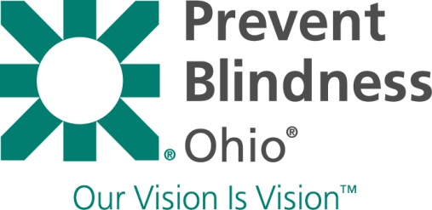

Story of Success Form
Prevent Blindness Ohio is a non-profit, public health organization that depends on funding and in-kind donations to ensure the success of our vision care programs. Sharing your true stories of success with donors keeps our programs operating. If you have received eye care through one of Prevent Blindness Ohio’s vision programs and it has made a difference in your life, we would like to know. Please complete this Story of Success Form and send it to Prevent Blindness Ohio, 1500 West Third Avenue, Suite 200, Columbus, OH 43212 or fax the form to 614-481-9670. Thank you. Please Print.

Agency Name (if applicable):
Your Story of Success:

(Use the reverse side of this form if additional space is needed)
-------------------------------------------------------------------------------------------------------------------------------

Your story helps our organization secure future funding so that we can continue to serve others.
Can we share your story with others? Yes ____ No_____
If you answer “Yes”, Prevent Blindness Ohio must obtain your consent to release your vision success story and/or photograph with third parties such as the media, donors and/or foundations.

I hereby authorize Prevent Blindness Ohio to use the written information above and/or photographs in materials including, but not limited to, press releases, marketing materials, brochures, reports, media broadcasts for up to 10 years from the date of this release.

First Name: Last Name:

Signature of Client or Parent/Guardian Date
Telephone Number:
Street Address:
City: State: Zip: County:

